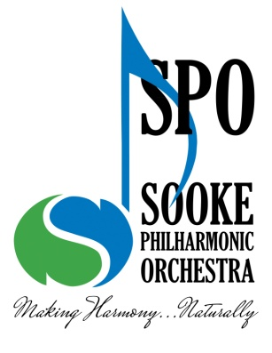
Sooke Philharmonic Society presents the 19th Annual
2024 Don Chrysler Concerto Competition for Young Musicians: Overview
The Don Chrysler Concerto Competition is open to instrumental and voice students up to and including the age of 25 years (as of January 1, 2024). They must be studying privately or at an accredited institution on Vancouver Island or the Gulf Islands.
The 1st prize winner will have the honour of performing as a soloist at two performances with the Sooke Philharmonic Orchestra. The concerts will take place on November 3, 2024 in Sooke, B.C.
Preliminary audition will be by recording. Those interested should complete the application form and submit it, together with your recording, postmarked no later than Friday, February 9, 2024. The recorded performance must be accompanied. In the case of a concerto, only the whole of the FIRST MOVEMENT, plus cadenza, if any, should be presented. In the case of a song cycle or similarly constructed composition, a minimum of 15 minutes of contrasting material is required. Finalists will be announced no later than March 1, 2024.
The final competition will take place on Monday, April 22, 2024 at 7:00 PM at the Phillip T Young Recital Hall, University of Victoria. This will be a live performance of the ENTIRE CONCERTO before a panel of judges and audience. Finalists must provide an accompanist where applicable. In the case of a pianist, there should be a second, accompanying pianist playing the orchestral parts, for which a second piano will be available. The works must be performed in their entirety, with no cuts in the opening tuttis, etc. The winners will be announced at the end of the concert.
There is no specific repertoire list to choose from. However, prior to preparing and submitting your application, you must contact the Music Director of the Sooke Philharmonic Orchestra to confirm the suitability of your selection. Failure to do so may invalidate your submission.
If a finalist is unable to meet the April 22nd competition date and rehearsal/concert dates (October 23, 30, Nov 1, and 3, 2024), he or she must notify the Music Director immediately.
The 1st prize winner will have the honour of performing as a soloist with the Sooke Philharmonic Orchestra. The concert will take place on November 3, 2024 at the Sooke Community Hall.
This package can be downloaded from our website: www.sookephil.ca For further information, please contact Jenny Nelson
Email: sookephilharmonic@gmail.com

