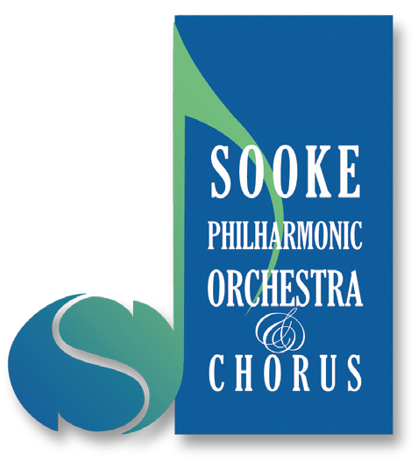
All memberships are by donation, and all donations are tax deductible.
Sooke Philharmonic Orchestra and Chorus

2017 - 18 Membership

Name(s):_____________________________________________________________

Address:________________________________________________________

City: ___________________________________Postal Code:_____________

Email: ________________ @________________Phone: _________________

Category | Donation | Donation Amount
Supporter | $25 - $99
Patron | $100 - $299
Principal | $300 - $499
Benefactor | $500 - $999
Maestro’s Circle | $1000+

Membership applications received by October 26, 2017 will be entered into a draw to win one of two dinners for two at Route 14 or Hara Sushi.

Acknowledgement of Support: Unless you wish to remain anonymous, your support will be acknowledged in the program for all concerts for the Season. Please indicate below.
I/We agree to having my/our name(s) published in the concert program | _______
I/We wish to remain anonymous | _______

Please mail the completed form and cheque, payable to Sooke Philharmonic Society, to:
Sooke Philharmonic Society, Box 767, Sooke, BC V9Z 1H7
To donate online, or for more information, please go to: sookephil.ca
Twenty years of making music!

