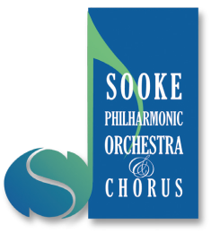

Sponsorship Support 2022-2023

Category | Annual contribution | Amount
Platinum | $1000+
Gold | $500-$999
Silver | $300-$499
Bronze | $100-$299

Acknowledgement of Support: Unless you wish to remain anonymous, your support will be acknowledged in the program for all concerts for the Season. Please indicate below.

Please initial
I/We agree to have our names published in concert programs: _______________

I/We wish to remain anonymous: _______________

Corporate Name:

Contact Name:

Address:

E-mail:

Telephone:

The Sooke Philharmonic Society appreciates your support!
Please mail the completed form and cheque, payable to Sooke Philharmonic Society to: Sooke Philharmonic Society, Box 767, Sooke, BC V9Z 1H7
Any Questions? Please email sookephilharmonic@gmail.com or call 250-419-3569

